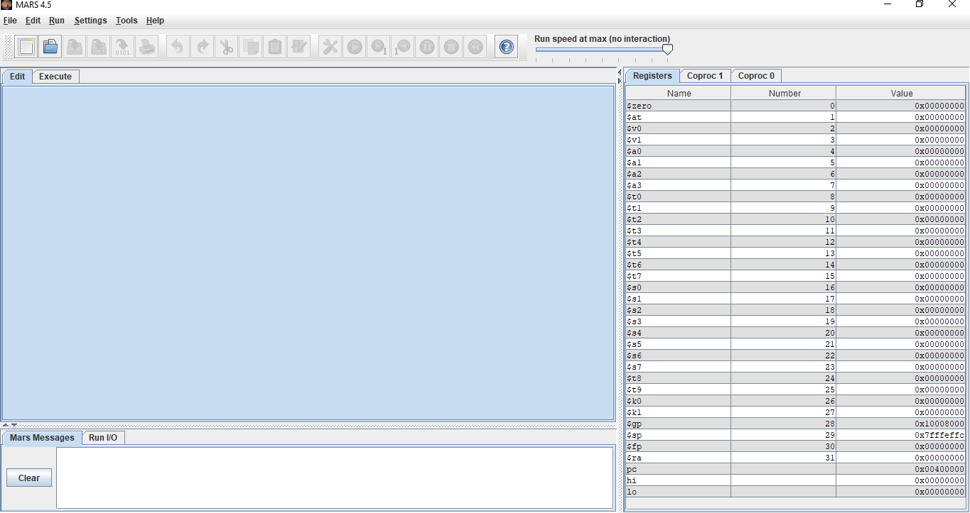
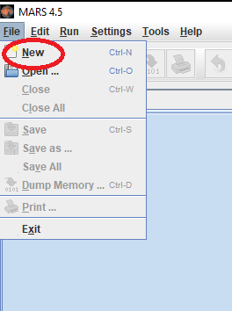
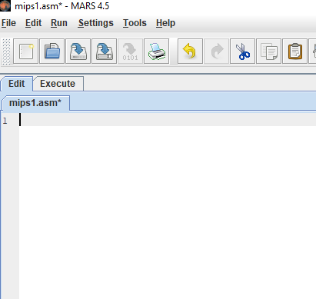
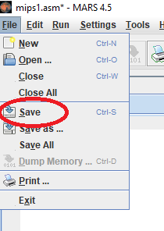
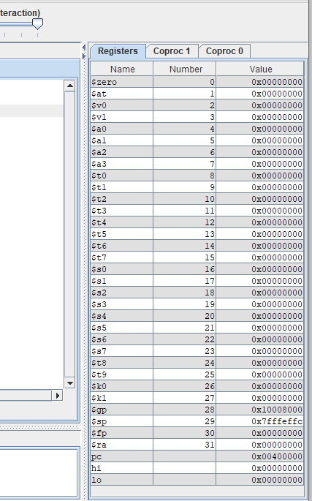
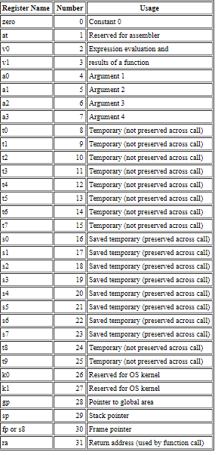
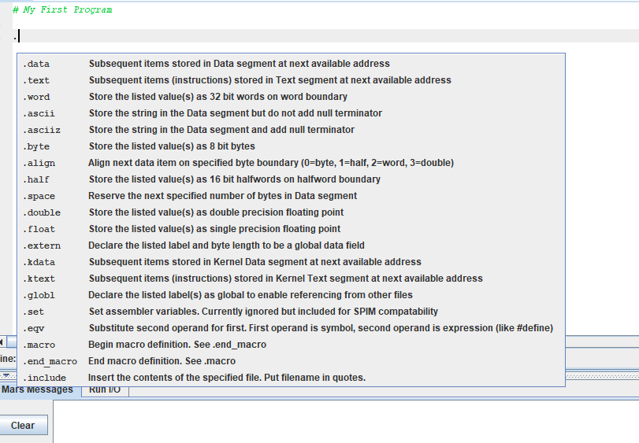
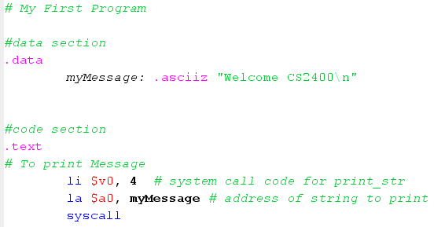

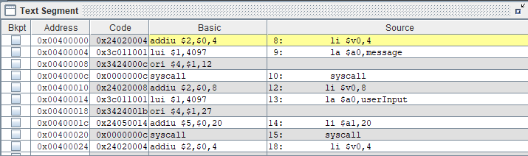
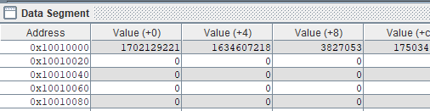





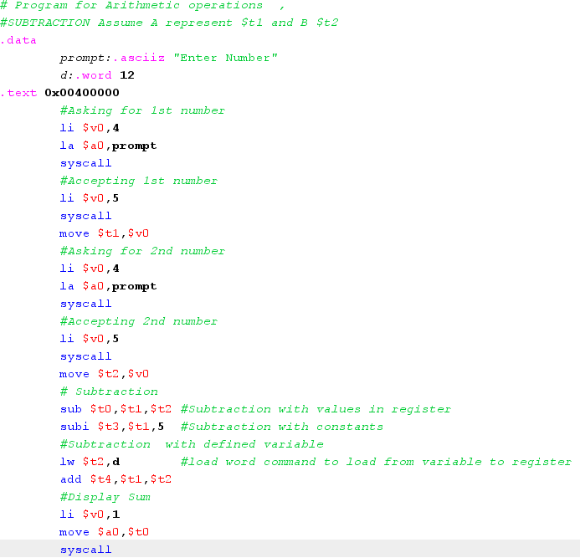
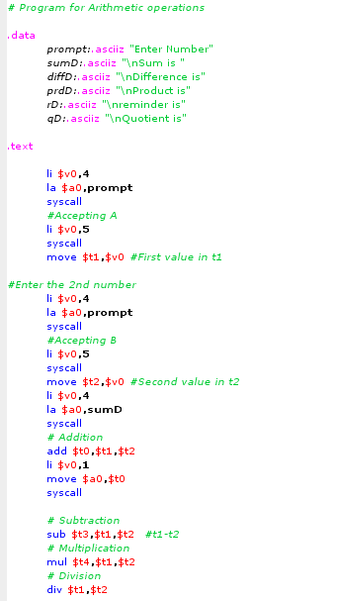
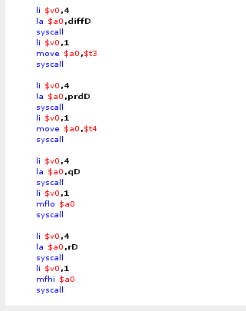
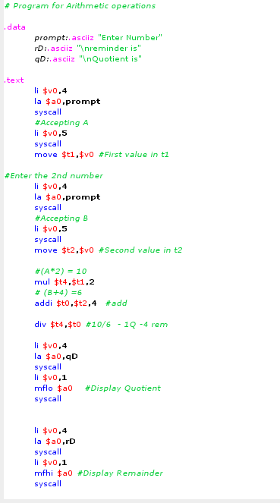
Introduction to MARS Simulator
(MIPS Assembler and Runtime Simulator)
MARS is a Java based Integrated Development Environment (IDE) for MIPS assembly language programming intended for educational use. We will explore the capabilities of MARS release 4.5 in this tutorial.
MARS may be downloaded from here. After downloading the executable file run the program, and launch MARS.

You should now be looking at a screen like this.
INITIAL SCREEN

Open a new file. Use File -> New. To open existing file use File->Open
A new file with name mips1.asm will open

Save the file using Save option from File menu, as “filename.asm” or “filename.s”
REGISTER DISPLAY
Other than being a powerful editor for assembly, MARS also gives information about the registers. This is helpful when trying to understand the PC counter, Stack Pointer, or other register values that are used. The registers display on the right side of the screen gives information about the register name, its number, and the value contained in that register at any point during the program execution. This is a valuable tool that runs in real time as the program is being executed. We can see that the value of the stack pointer in this example, and the value of the PC counter before its offset.
WRITING CODE
- Any statement starting with a ‘#’ will be commenting statements which are not counted during execution.
Example
# My First Program.

- MARS is an IDE, this means that when you type code, there is interaction between you and the program that gives you information about the code you are writing, as you write it. So when you put a dot in the screen, you can see the interactive screen popping up.

ASSEMBLING
Choose from menu Run -> Assemble or press F3
This button in toolbar is used to initiate the assembly operation
Once the code was written to the “Edit” region of the simulator, the “assemble” operation is performed and the screen switches to the “Execute” tab. The execute tab has multiple regions and the code text resides in the “Text Segment” as shown below.
The text segment segregates the instructions and each instruction is identified with multiple attributes.
The “Address” tab holds the memory address at which the instruction resides.
The “Code” is a hexadecimal representation of the instruction in machine language. Note that this is a 32 bits long MIPS instruction.
The “Source” is the direct textual representation of the written code, along with comments.
The “Bkpt” is the breakpoint toggle checklist. More about this will be discussed in the coming sections.

The addresses (32 bit) and their holding values of the program-based memory transactions can be found at the “Data Segment” (shown below) region of the simulator. This is an array of memory locations which hold the respective values and is updated in run time.

RUNNING THE PROGRAM

Toolbar

In MARS, run the program using the Run toolbar button or Run->Go or press F5.
To run step by step use toolbar button or Run-> Step or press F7.
To reset use toolbar button or Run-> Reset or press F12
To backstep to the previous instruction press F8 or button in toolbar.

RUNTIME IO AND ARRAYS

A list of “syscalls” are provided at this link. You will need to make the appropriate “syscalls” to do any form of IO, any console IO will appear in the Run I/O tab in MARS.
MIPS also provides a few ways to handle data in arrays. Strings are a special case of arrays, where the elements are one byte characters (in the ASCII encoding scheme), terminated with the null character (ASCII character 0). The null character is necessary in many languages so that functions handling the string know where it ends.

Example Section

Program1 –
# Program for accept a number message
#data section
.data
prompt: .asciiz "Enter the number: "
myMessage: .asciiz "The number is \n"
#code section
.text
#To prompt the user
li $v0, 4 # System call parameter in v0 to print string
la $a0, prompt # loading address of string variable to print
syscall
#get value from the Console
li $v0,5
syscall
#Store the result in a temp reg
move $t0,$v0
#To print the message
li $v0, 4 # System call parameter in v0 to print string
la $a0, myMessage # loading address of string variable to print
syscall
#To print a number
li $v0,1 # system call for int
move $a0,$t0 # load the int to print
syscall

Program 2- Arithmetic operations

Arithmetic operations Classwork 01

Arithmetic operations Classwork 02

